ARDC No.: 6296022
STATE OF ILLINOIS
COUNTY OF SANGAMON

IN THE CIRCUIT COURT OF THE 7TH JUDICIAL CIRCUIT,
SANGAMON COUNTY, SPRINGFIELD, ILLINOIS

SELENE FINANCE LP | Case No. 17 CH 000199
Plaintiff,
vs.

GREGORY GRIFFIN SR A/K/A GREG GRIFFIN, STACY A GRIFFIN, ILLINOIS HEALTHCARE AND FAMILY SERVICES; UNKNOWN OWNERS AND NON-RECORD CLAIMANTS | Property Address:  2813 BLACK AVE  SPRINGFIELD, IL 62702
Defendant(s).

NOTICE OF MOTION

PLEASE TAKE NOTICE that on _________, 2018 at 09:00 AM, or as soon thereafter as Counsel may be heard, I shall appear before the Honorable Judge sitting in Courtroom ________ of _____________________________________________ Illinois, and then and there move the Court for entry of Order to Appoint of Special Process Server.
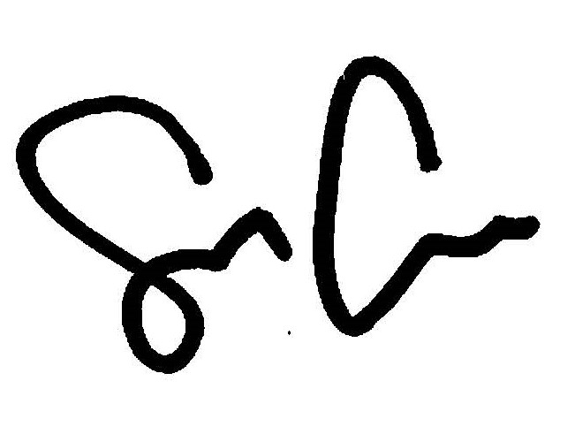
By: ___________________________________
Shaun Callahan
Marinosci Law Group, P.C.

CERTIFICATE OF SERVICE

I, _______________________________, certify that I served a copy of this notice with attached Motions by mailing the same to the members of the attached service list and placed said envelope in the U.S. Mail at a U.S. Post Office located in Chicago, Illinois before the hour of 5:00 p.m., with proper postage fully prepaid, on ________________.

Signature: _________________________________
_________________________________

Marinosci Law Group, P.C.
134 N. LaSalle St.
Suite 1900
Chicago, IL 60602
Tel: 312.940.8580
Fax: 401.234.5130
ARDC No.: 6299506
mlgil@mlg-defaultlaw.com
SERVICE LIST

GREGORY GRIFFIN SR A/K/A GREG GRIFFIN
2813 E BLACK AVE
SPRINGFIELD, IL 62702

STACY A GRIFFIN
433 N. 13TH ST
SPRINGFIELD, IL 62702

ILLINOIS HEALTHCARE AND FAMILY SERVICES
11 STONE AVENUE
NORTH AURORA, IL 60542

UNKNOWN OWNERS AND NON-RECORD CLAIMANTS
2813 BLACK AVE
SPRINGFIELD, IL 62702

ARDC No.: 6299506
STATE OF ILLINOIS
COUNTY OF SANGAMON

IN THE CIRCUIT COURT OF THE 7TH JUDICIAL CIRCUIT,
SANGAMON COUNTY, SPRINGFIELD, ILLINOIS

SELENE FINANCE LP | Case No. 17 CH 000199
Plaintiff,
vs.

GREGORY GRIFFIN SR A/K/A GREG GRIFFIN, STACY A GRIFFIN, ILLINOIS HEALTHCARE AND FAMILY SERVICES; UNKNOWN OWNERS AND NON-RECORD CLAIMANTS | Property Address:  2813 BLACK AVE  SPRINGFIELD, IL 62702
Defendant(s).

MOTION FOR THE APPOINTMENT OF SPECIAL PROCESS SERVER

Now comes Plaintiff, SELENE FINANCE LP., by and through its attorneys, MARINOSCI LAW GROUP, P.C., and pursuant to 735 ILCS 5/2-202 moves this court for the entry of an Order appointing Firefly Legal, Inc., a licensed private detective agency, IL License Number 117.001465, and its employees as special process server to make service of process in this case, on all defendants located within Cook County, and in support thereof states as follows:

1. Immediate service of process is necessary to protect the interests of the plaintiff herein.

2. Firefly Legal, Inc., certified under the Private Detective, Private Alarm, Private Security Act is a licensed private detective agency in the State of Illinois, IL License Number 117.001465, and its employees are over 18 years of age and are not parties to this action.

WHEREFORE, SELENE FINANCE LP, prays for the appointment of Firefly Legal, Inc., and its employees as private process server herein to serve process in this matter.
Respectfully submitted,

By: ___________________________________
Shaun Callahan
Attorney, Marinosci Law Group, P.C.

Marinosci Law Group, PC

134 N. LaSalle, Ste 1900. Chicago, IL 60602

T: 312-940-8580 // F: 401-234-5130

ARDC No.: 6312967

mlgil@mlg-defaultlaw.com

ARDC No.: 6296022
STATE OF ILLINOIS
COUNTY OF SANGAMON

IN THE CIRCUIT COURT OF THE 7TH JUDICIAL CIRCUIT,
SANGAMON COUNTY, SPRINGFIELD, ILLINOIS

SELENE FINANCE LP | Case No. 17 CH 000199
Plaintiff,
vs.

GREGORY GRIFFIN SR A/K/A GREG GRIFFIN, STACY A GRIFFIN, ILLINOIS HEALTHCARE AND FAMILY SERVICES; UNKNOWN OWNERS AND NON-RECORD CLAIMANTS | Property Address:  2813 BLACK AVE  SPRINGFIELD, IL 62702
Defendant(s).

ORDER APPOINTING A SPECIAL PROCESS SERVER

THIS CASE COMING TO BE HEARD on Plaintiff’s Motion to Appoint Firefly Legal, Inc. as a Special Process Server, with the Court being advised in the premises:
THE COURT HEREBY:

1. Appoints Firefly Legal, Inc., (IL License No. 117.001465), as a Special Process Server – authorized to make service of process in Cook County in the above-captioned case.

Enter: _________________________________

Date: __________________________________

Marinosci Law Group, PC

134 N. LaSalle, Ste 1900. Chicago, IL 60602

T: 312-940-8580 // F: 401-234-5130

ARDC No.: 6296022

mlgil@mlg-defaultlaw.com

